Mac and Linix FishRand Installation Instructions

1. Go to the FishRand Directory double click on mac_installer. A terminal window should appear and execute a bunch of commands.

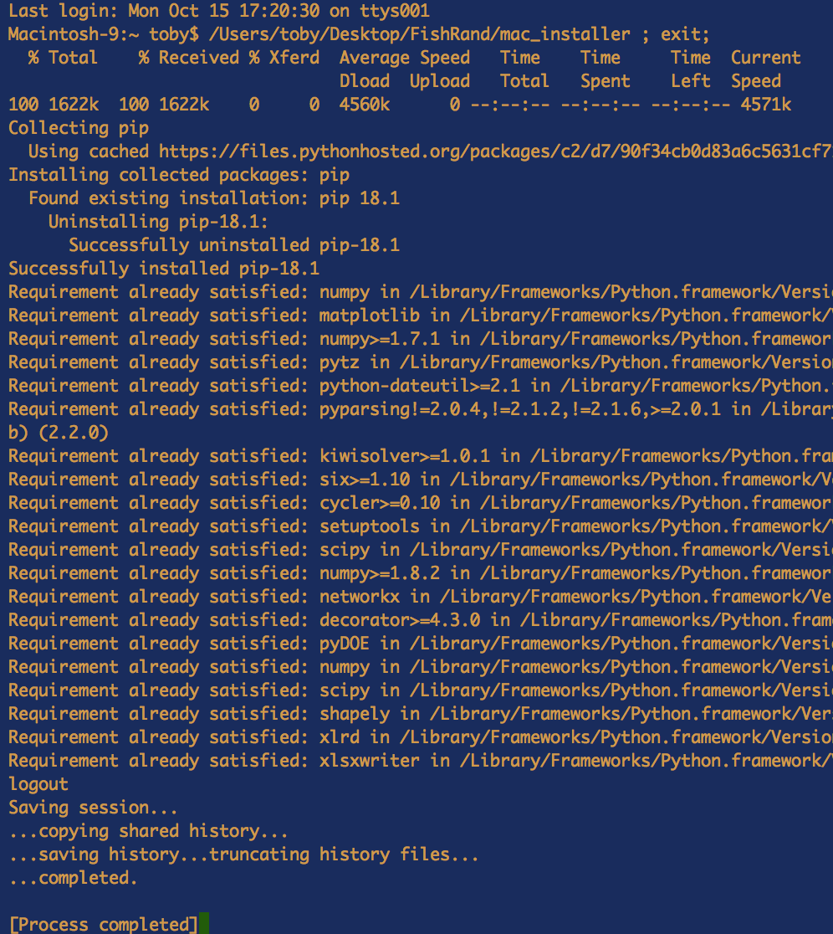

1. Every time you want to run FishRand from now on you can double click on the file in the FishRand directory named FishRand (with no extension).

